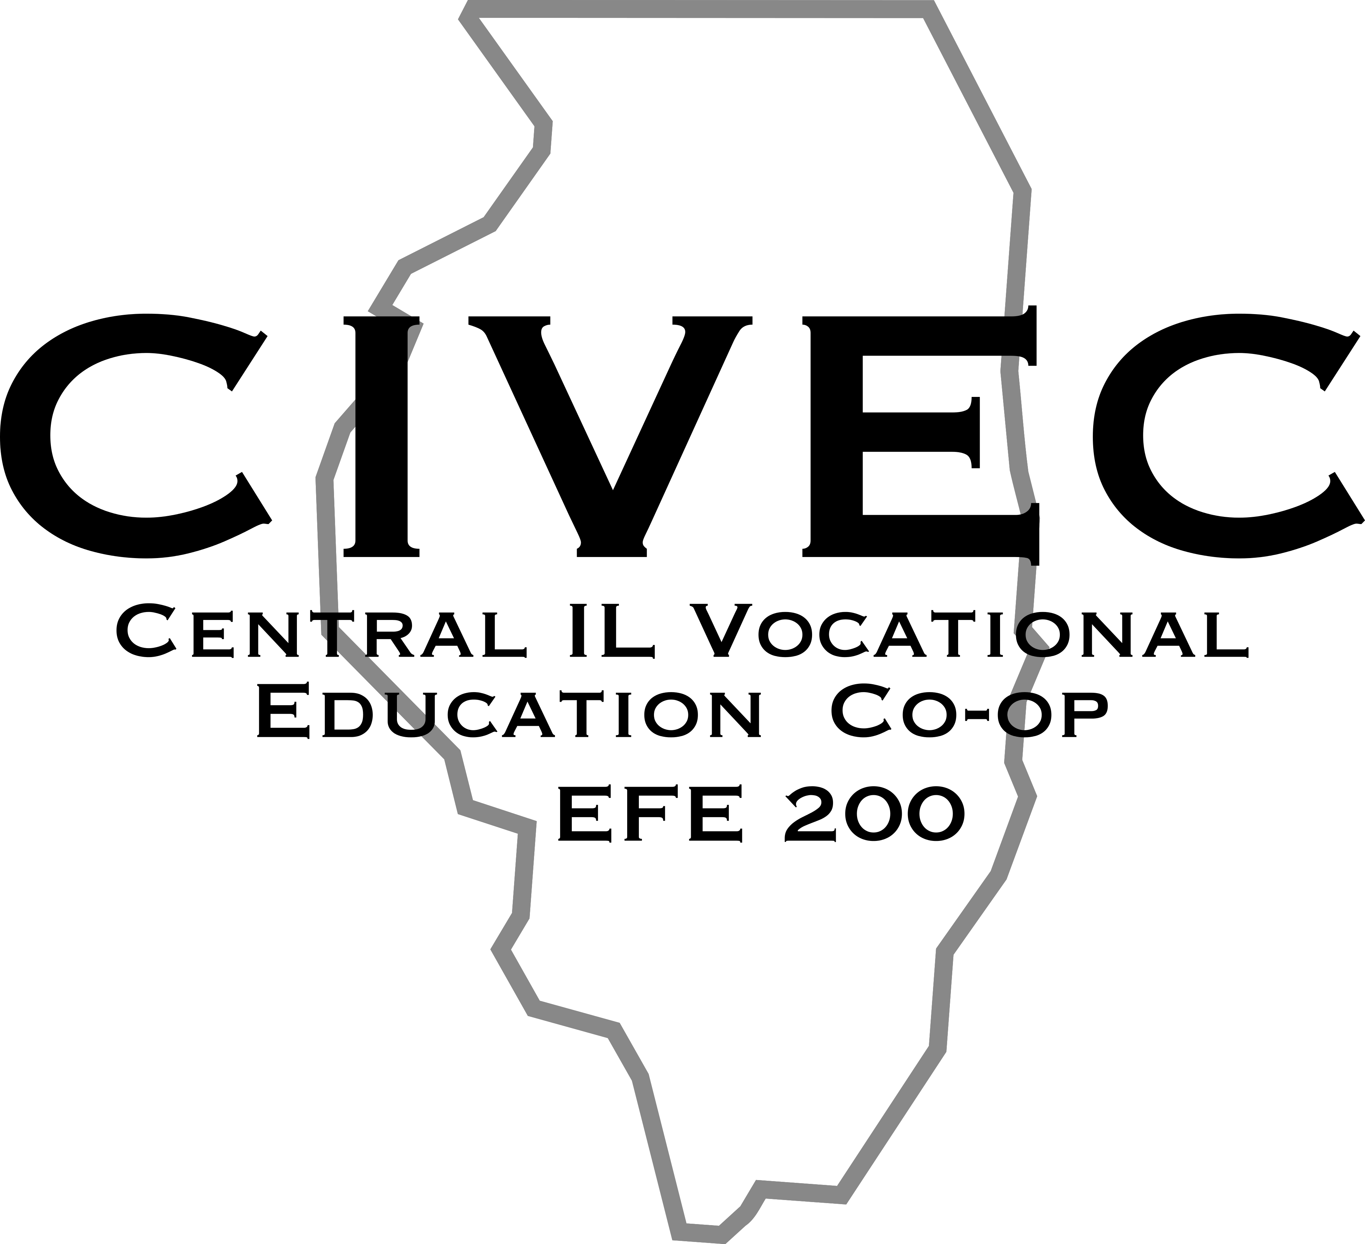
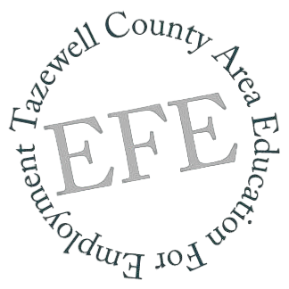
Regional Student Services

Committee Meeting
Friday, December 8, 2023
AGENDA
9:30am - 10:45am VIVO
195 East Martin Drive, Goodfield, IL 61742
- Tour facility
11:00am - 12:00pm The Barn III & CEO
1451 Timberline Rd, Goodfield, IL 61742
- Discussing Entrepreneurship 12:00pm - 12:30pm Lunch (The Barn III) and Networking
1:00pm - 2:30pm Eureka College - Terrill Room (map)
300 E College Ave, Eureka, IL 61530
- Greetings from College President
& Admissions Counselor
- Campus Tour
- Panel Discussion
Please RSVP by Monday, November 27, 2023 by clicking HERE

