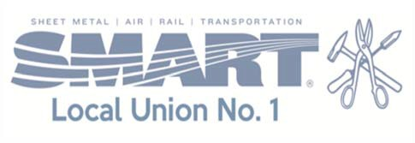

FY 2019 Regional

Student Services Committee

Friday, April 12, 2019

LOCATION:

Sheet Metal Workers Local 1

840 W. Birchwood Street

Morton, Illinois 61550

Ph (309) 682-5677

AGENDA:

10:30 a.m.

Sign-in and Welcome

11:00 a.m.

Sheet Metal Industry & Apprenticeship Program

Hands-on Activity

12:30 p.m.

Networking and Lunch

Jimmy John’s (Choices: Turkey, Ham, Veggie)

1:30 p.m.

Wrap-up Topics & End of Year Survey

2:00 p.m.

Adjourn

Please RSVP with lunch preference to: [azarvell@perfectpeoria.com](mailto:azarvell@perfectpeoria.com)

by Friday, April 5, 2019.