Just What Exactly is
Work-Based Learning?

ork-based learning links secondary and post-secondary education, business and industry, labor and government to provide high school students with a wide range of career opportunities and experiences, leading to a smooth
W
transition from school to work. Work-based learning students come to realize the connection between school and living productive lives. Competency-based work-based learning experiences include non-paid internships, occupational/ technical labs, and related high school coursework. Many work-based learning programs also include additional career exploration activities like job shadowing, speakers, field trips and workshops. Benefits to work-based learning are numerous (see box below). Both educators and business sponsors provide students with the employability and career- related skills they need to be productive members of the workforce. Thus, work-based learning programs serve as a vital link between education and careers.

P.E.R.F.E.C.T., Tazewell County/Area Education For Employment, the Central Illinois Vocational Education Cooperative, and Illinois Central College have partnered to provide Central Illinois 11th and 12th grade high school students with region-wide work-based learning programs. Visit the high school guidance office for more information.

How Do Students Benefit From WBL?
✓ Exposure to variety of careers
✓ Hands-on, competency-based training
✓ Related high school coursework
✓ High school credit
✓ Advanced college/apprenticeship placement
✓ Dual credit
✓ Scholarships
✓ Opportunities for quality jobs
✓ Potential contacts for employment and post-secondary education
✓ Connection or “link” between school and work
✓ Self-confidence from success at school and work

How Do Employers Benefit From WBL?
✓ Provide students with a better understanding of a career field
✓ Influence student development to meet industry requirements
✓ Have expanded pool of qualified applicants
✓ Evaluate potential employees
✓ Feel pride and importance in collaborating with education

How Do Educators Benefit From WBL?
✓ Increased college/apprenticeship placement and employment rates of graduates
✓ Opportunities for professional staff development
✓ Increased enrollment in career and technical courses
✓ Instruction integrated with actual work and life experience
✓ Improved attendance, reduced drop-out rate

How Does The Community Benefit From WBL?
✓ Development of skilled workforce
✓ Enhanced employability of youth
✓ Decreased stress on families and community from unmotivated youth
✓ Economic growth and higher quality of life through expanded skilled workforce and taxpayer base
✓ Pride in schools and investing in youth
Application

Work-based learning program information and application forms can be found in each high school’s guidance department. Application information is also available online at:
www.perfectpeoria.com

For more information or to schedule a presentation for your school, please contact:

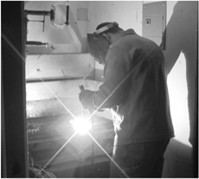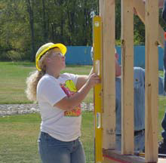Chris Kendall, Director Peoria Educational Region For Employment and Career Training (309) 693-7373

